7.14: a) At the top of the swing, when the kinetic energy is zero, the potential energy (with respect to the bottom of the circular arc) is 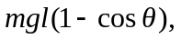 where l is the length of the string and is the angle the string makes with the vertical. At the bottom of the swing, this potential energy has become kinetic energy, so 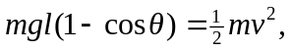 or . b) At 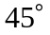 from the vertical, the speed is zero, and there is no radial acceleration; the tension is equal to the radial component of the weight, or c) At the bottom of the circle, the tension is the sum of the weight and the radial acceleration,
or 1.9 N to two figures. Note that this method does not use the intermediate calculation of v.

